Department of Computer Technology

Vision of the Department
To be a well-known centre for pursuing computer education through innovative pedagogy, value-based education and industry collaboration.

Mission of the Department
To establish learning ambience for ushering in computer engineering professionals in core and multidisciplinary area by developing Problem- solving skills through emerging technologies.

Practical Number | Practical no 3
Course Outcome | - Understand Computer System Configuration and Simulate system resources efficiently using Linux Commands (CO1)  - Analyse operating system functionalities utilizing system calls, thread programming and process scheduling  algorithms (CO2)  - Apply Synchronization primitives to implement a Deadlock-free solution(CO3)  - Simulate Disk scheduling, Memory allocation, File allocation, page replacement algorithms (CO4)
Aim | Implement Thread life cycle : Thread creation and Termination
Problem Definition | CHAT APPLICATION STIMULATION  Create two threads One for sending message and One for receiving messgaes . They should run independently and terminate after exchanging 5 messages each.
Theory  (100 words) | Threads  A thread is the smallest unit of execution inside a process. Multiple threads can share the same memory and resources, allowing tasks to run at the same time and improving performance, especially on multi-core CPUs.  Thread Life Cycle  - New – Thread is created but not running.  - Runnable – Ready to run, waiting for CPU.  - Running – Actively executing.  - Waiting / Blocked – Paused, waiting for an event or resource.  - Terminated – Finished execution, resources released.  POSIX Threads (pthreads)  Pthreads are a standard way to use threads in UNIX-like systems. They let you create, manage, and synchronize threads using functions like pthread_create, pthread_join, and synchronization tools like mutexes and condition variables.  Mutex (Mutual Exclusion)  A mutex is a lock that ensures only one thread can access a shared resource at a time, preventing race conditions. Common operations are:  - Initialize: pthread_mutex_init  - Lock: pthread_mutex_lock  - Unlock: pthread_mutex_unlock  - Destroy: pthread_mutex_destroy
Procedure and Execution  (100 Words) | Step for Implementation:  1 Set up the environment  - Decide that two threads will be used: one to send messages and one to receive them.  - Pick a safe way to let both threads read and write a shared message area without corrupting it — a mutex is the simplest choice.  2 Plan shared data  - You need a buffer where a message can be stored temporarily so that both threads can access it.  - Counters are useful to keep track of how many messages have been sent and how many have been read.  - These shared variables must be protected with a mutex so only one thread changes or reads them at a time.  3 Design the sender thread  - It should loop until a fixed number of messages (e.g., five) are sent.  - Inside the loop, it locks the mutex, writes the next message into the shared buffer, updates the sent counter, prints confirmation, and then unlocks the mutex.  - A short pause can be added to mimic asynchronous behavior.  ]4 Design the receiver thread  - It should loop until it has received the same number of messages.  - Each time around, it locks the mutex, checks whether a new message is available (by comparing sent and received counters).  - If a new message is there, it prints it and updates the received counter. Then it unlocks the mutex and waits briefly before checking again.  5 Integrate with main control flow  - Before starting threads, initialize the mutex.  - Create both threads, giving one the sender function and the other the receiver function.  - Wait for both threads to finish their loops.  - When both are done, clean up (destroy the mutex if needed) and display a final summary that the chat exchange is complete.  6 Test and verify  - Compile and run the program.  - Make sure that the sending and receiving happen without overlap or data corruption, and that exactly the expected number of messages are exchanged.
Code:
#include <pthread.h>
#include <stdio.h>
#include <stdlib.h>
#include <string.h>
#include <unistd.h>

#define TEXT_LIMIT 256
#define TOTAL_EXCHANGES 5

char shared_text[TEXT_LIMIT];
int count_sent = 0;
int count_received = 0;
pthread_mutex_t guard;

void *writer_thread(void *unused) {
while (count_sent < TOTAL_EXCHANGES) {
pthread_mutex_lock(&guard);
printf("Type message %d: ", count_sent + 1);
fgets(shared_text, TEXT_LIMIT, stdin);
shared_text[strcspn(shared_text, "\n")] = '\0';
count_sent++;
printf("Writer: %s\n", shared_text);
pthread_mutex_unlock(&guard);
usleep(100000);
}
return NULL;
}

void *reader_thread(void *unused) {
while (count_received < TOTAL_EXCHANGES) {
pthread_mutex_lock(&guard);
if (count_sent > count_received) {
printf("Reader got: %s\n", shared_text);
count_received++;
}
pthread_mutex_unlock(&guard);
usleep(100000);
}
return NULL;
}

int main(void) {
pthread_t writer, reader;

if (pthread_mutex_init(&guard, NULL) != 0) {
fprintf(stderr, "Could not set up mutex\n");
return EXIT_FAILURE;
}

if (pthread_create(&writer, NULL, writer_thread, NULL) != 0) {
fprintf(stderr, "Could not launch writer\n");
return EXIT_FAILURE;
}

if (pthread_create(&reader, NULL, reader_thread, NULL) != 0) {
fprintf(stderr, "Could not launch reader\n");
return EXIT_FAILURE;
}

pthread_join(writer, NULL);
pthread_join(reader, NULL);

printf("Conversation ended after %d exchanges.\n", TOTAL_EXCHANGES);

pthread_mutex_destroy(&guard);
return EXIT_SUCCESS;
}
Output:
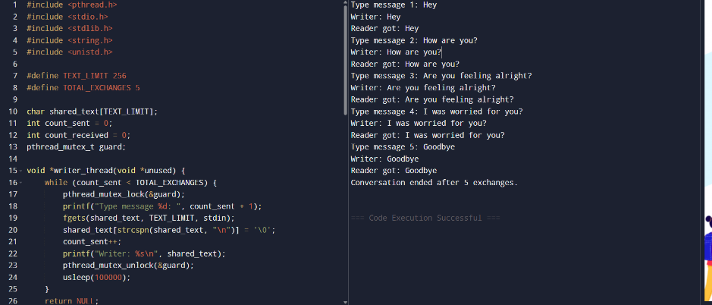
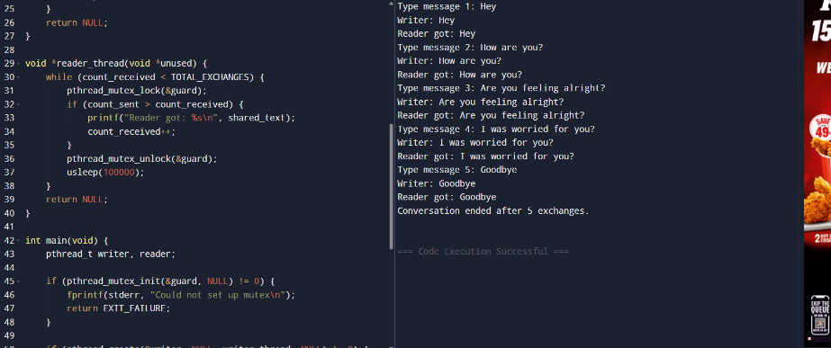

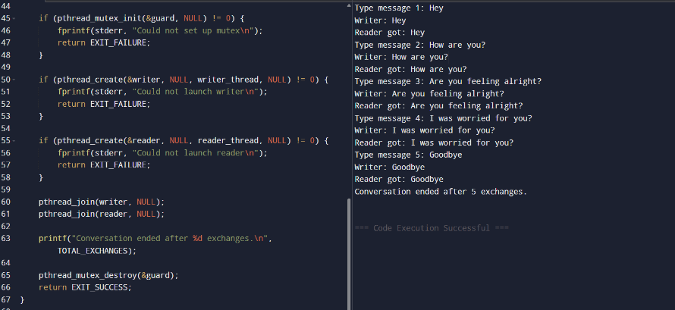

Department of Computer Technology

Vision of the Department
To be a well-known centre for pursuing computer education through innovative pedagogy, value-based education and industry collaboration.

Mission of the Department
To establish learning ambience for ushering in computer engineering professionals in core and multidisciplinary area by developing Problem- solving skills through emerging technologies.

Output Analysis | The program runs two threads at the same time. One asks the user for five messages and confirms each one. The other reads those messages and displays them. This back-and-forth continues until all five are exchanged, then the program prints a closing line to show the conversation is finished. The exact order of lines may vary slightly because both threads work in parallel, but every message is delivered and read once without errors.
Link of student Github profile where lab assignment has been uploaded
Conclusion | Thus we successfully solved the problem statement using threads in C.
Plag Report (Similarity index < 12%) | 
Date | 20 August 2025

